**Assignment 3**

**FIFA Matches**

**Que 1:** To load the FIFA 2020 dataset and display its first five rows to understand its structure and contents for further analysis.

**Ans:**

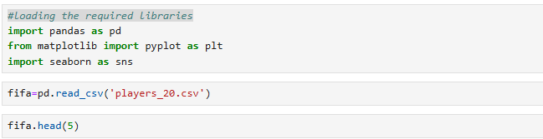

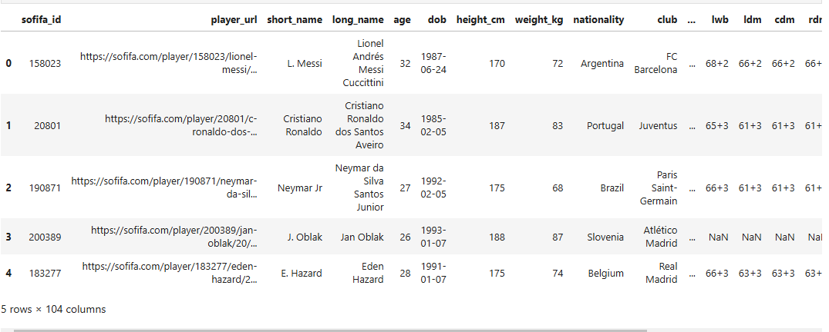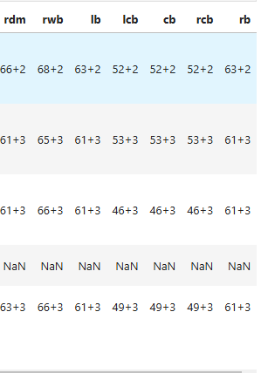

**Que 2:** To load and examine the FIFA 2020 dataset by displaying its initial rows

**Ans:**



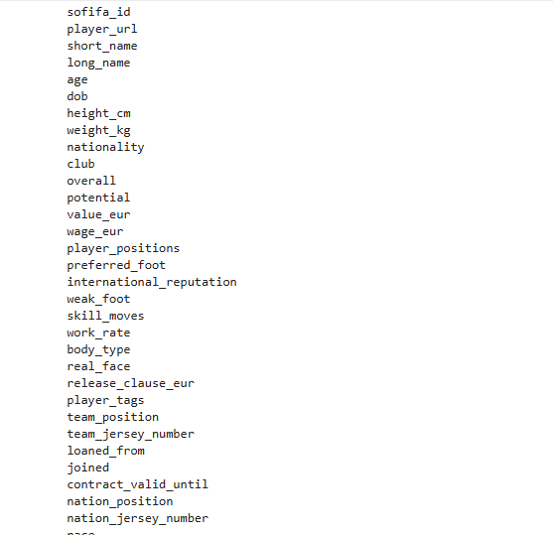

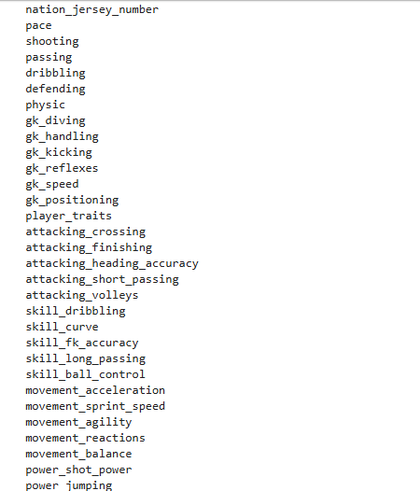

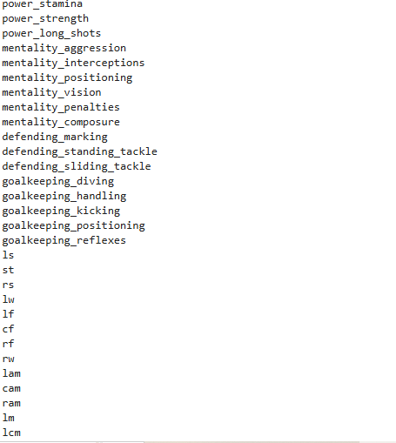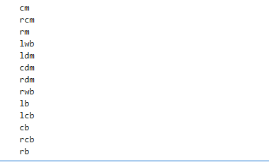

**Que 3:** Create or display the dimensions (number of rows and columns) of the FIFA 2020 dataset using the .shape attribute

**Ans:**

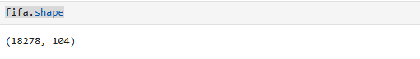

**Que 4:** Display the result of multiplying the number of rows (18,278) by the number of columns (104) in the FIFA 2020 dataset represent

**Ans:**

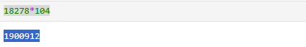

**Que 5:** Display the result of dividing 1,667 by 18,278 represent in the context of the FIFA 2020 dataset

**Ans:**

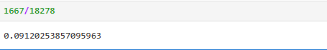

**Que 6:** Display the result to show the number of players from each nationality in the FIFA 2020 dataset?

**Ans:**

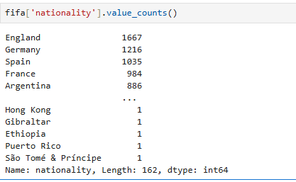

**Que 7:** Display the top 10 nationalities with the highest number of players in the FIFA 2020 dataset

**Ans:**

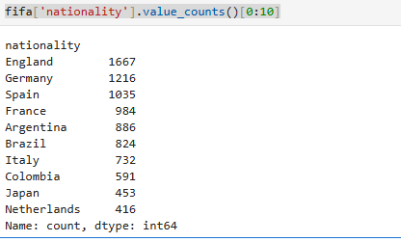

**Que 8:** Display the names of the top 5 nationalities with the highest number of players in the FIFA 2020 dataset

**Ans:**



**Que 9:** Display the top 5 nationalities with the highest number of players in the FIFA 2020 dataset, along with their respective player counts

**Ans:**

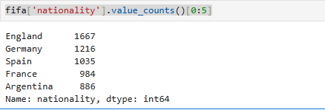

**Que 10:** Create a bar chart displaying the top 5 nationalities with the highest number of players in the FIFA 2020 dataset

**Ans:**

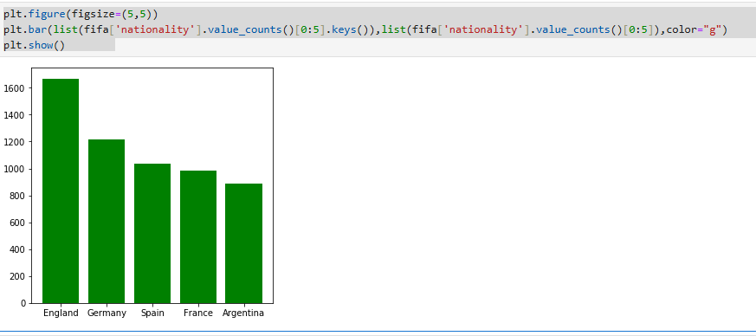

**Que 11:** Extract and display the top 5 players' names and their respective wages in Euros from the FIFA 2020 dataset

**Ans:**

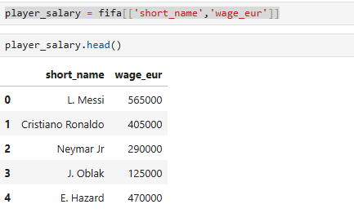

**Que 12:** Sort the players by their wages in descending order and display the top 5 players

**Ans:**

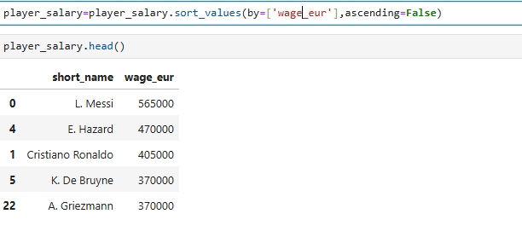

**Que 13:** Create a bar chart displaying the top 5 players and their wages in Euros from the FIFA 2020 dataset, with each bar in a different color

**Ans:**

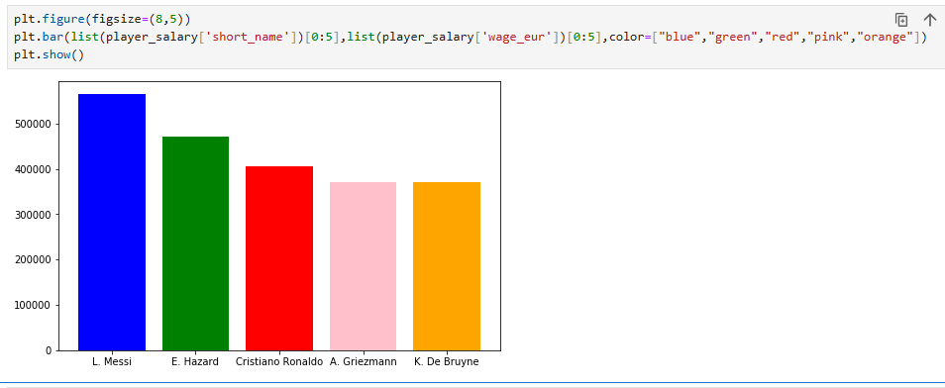

**Que 14:** Filter the FIFA 2020 dataset to display players whose nationality is Germany

**Ans:**

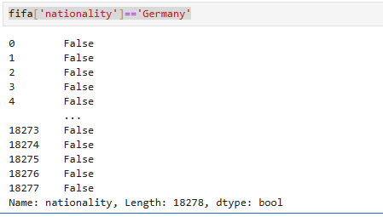

**Que 15:** Filter the FIFA 2020 dataset to display the top 10 players whose nationality is Germany

**Ans:**



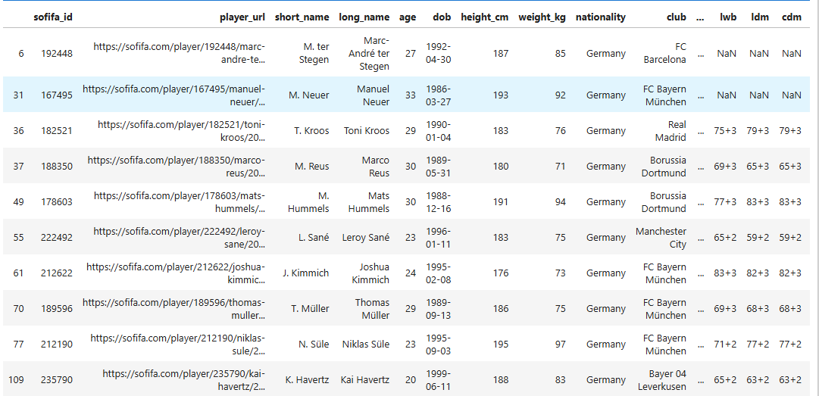

**Que 16:** Sort the German players in the FIFA 2020 dataset by their height in descending order and display the top players

**Ans:**

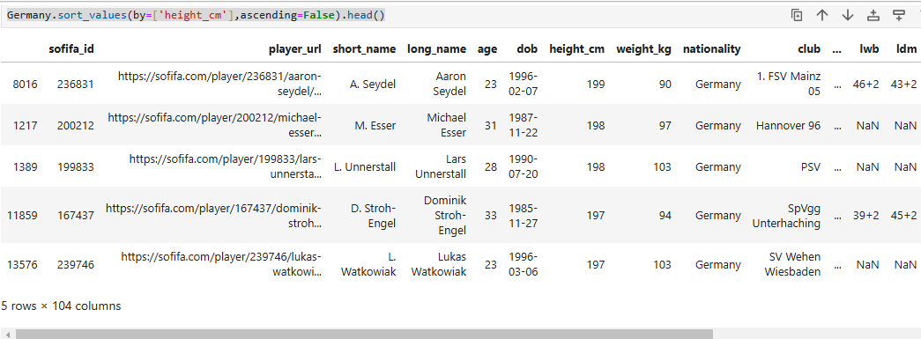

**Que 17:** Sort the German players in the FIFA 2020 dataset by their weight in descending order and display the top players

**Ans:**

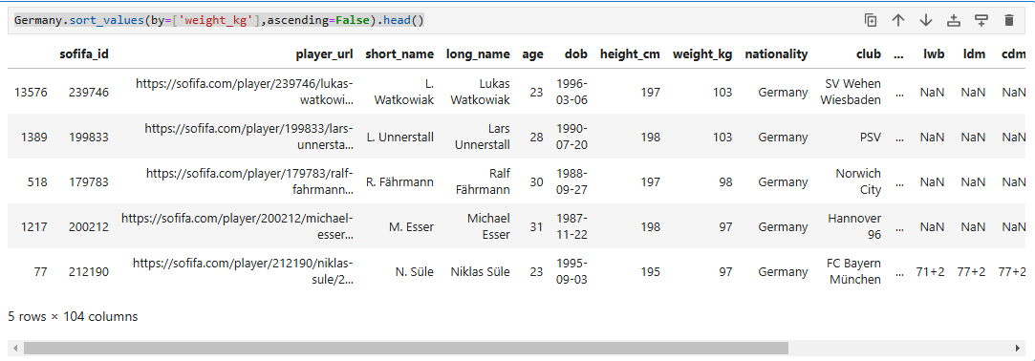

**Que 18:** Sort the German players in the FIFA 2020 dataset by their wage in Euros in descending order and display the top players

**Ans:**

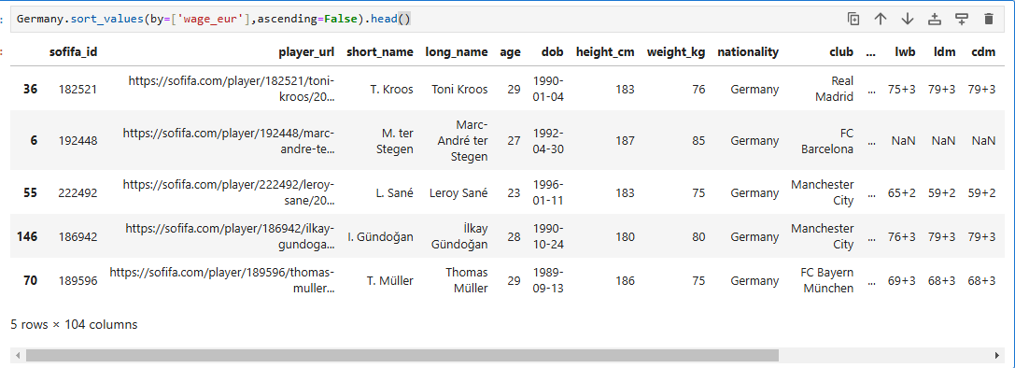

**Que 19:** Display the top 5 German players with the highest wages in Euros by selecting their names and wages, and sorting in descending order

**Ans:**

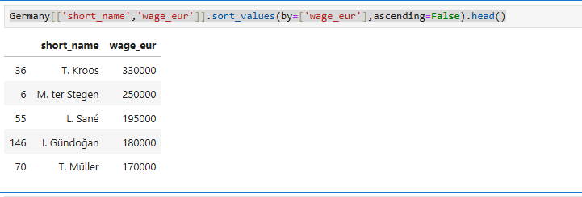

**Que 20:** Display the top 5 players with the highest shooting attribute from the FIFA 2020 dataset

**Ans:**

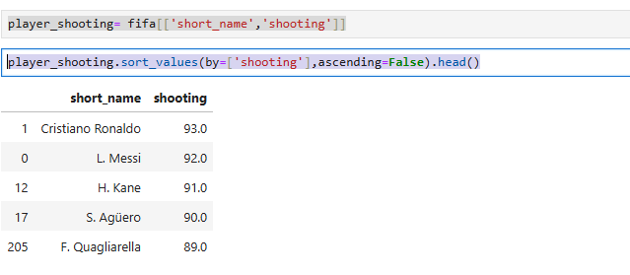

**Que 21:** Display the top 5 players with the highest defending attribute from the FIFA 2020 dataset, along with their nationality and club

**Ans:**

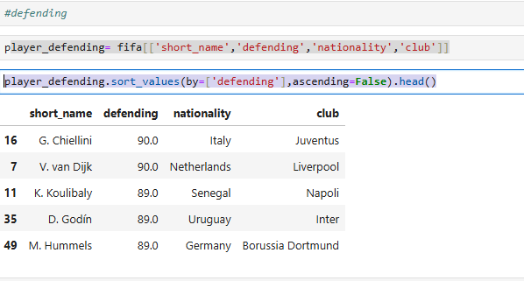

**Que 22:** Filter the FIFA 2020 dataset to display the top 5 Real Madrid players with the highest wages in Euros, sorted in descending order

**Ans:**

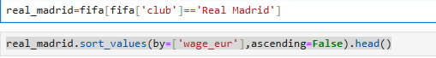

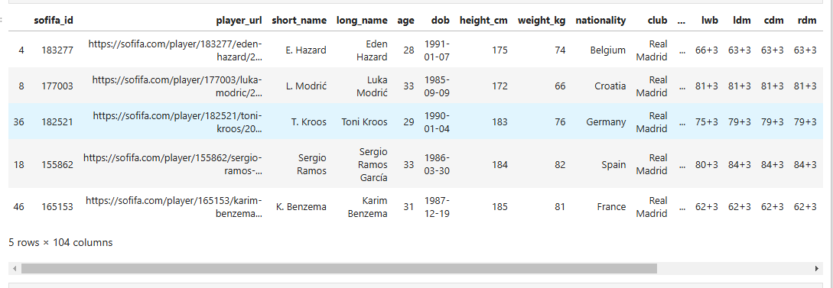

**Que 23:** Filter the FIFA 2020 dataset to display the top 5 Real Madrid players with the highest shooting attributes, sorted in descending orde

**Ans:**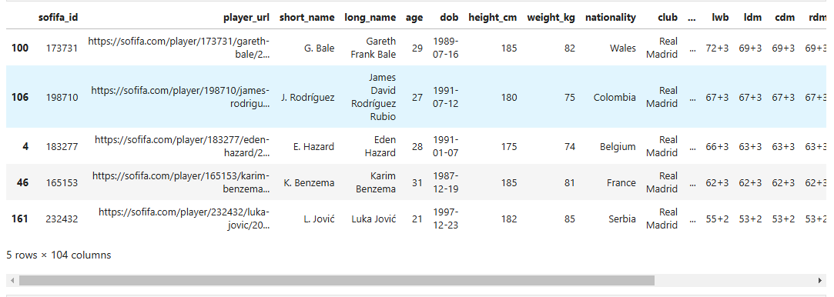

**Que 24:** Filter the FIFA 2020 dataset to display the top 5 Real Madrid players with the highest defending attributes, sorted in descending order

**Ans:**



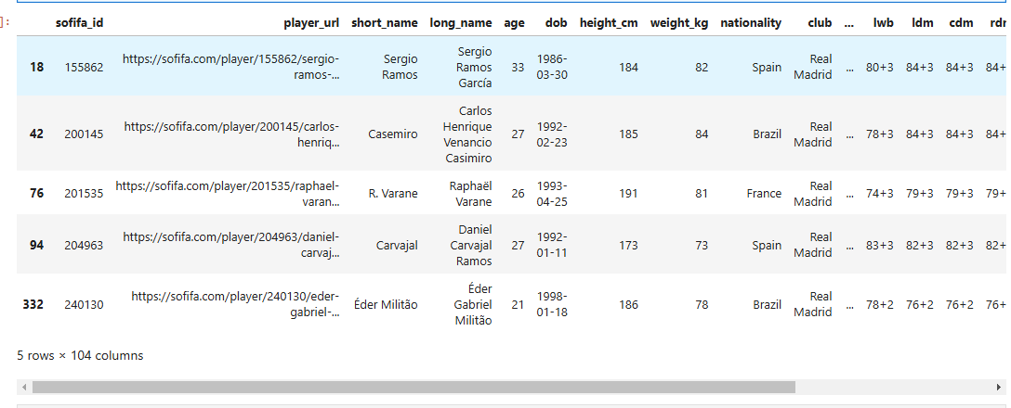

**Que 25:** Display the distribution of nationalities among the Real Madrid players in the FIFA 2020 dataset

**Ans:**

